

Assignment 01

Aitzaz Tahir Ch 19p0012

SDA Bs(CS)-B



**Actors and use-case diagram for HMS case study.**

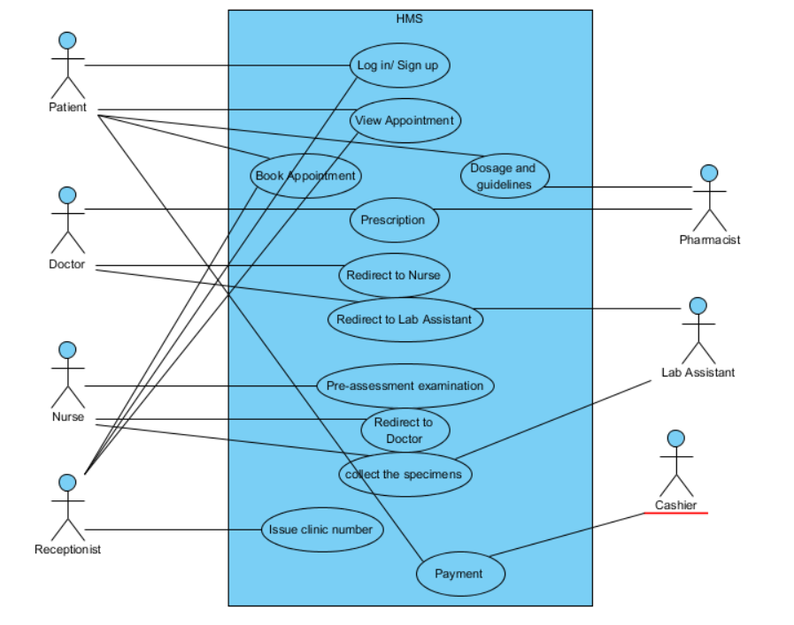

**Activity Diagram.**

**Activity diagram of patients:**

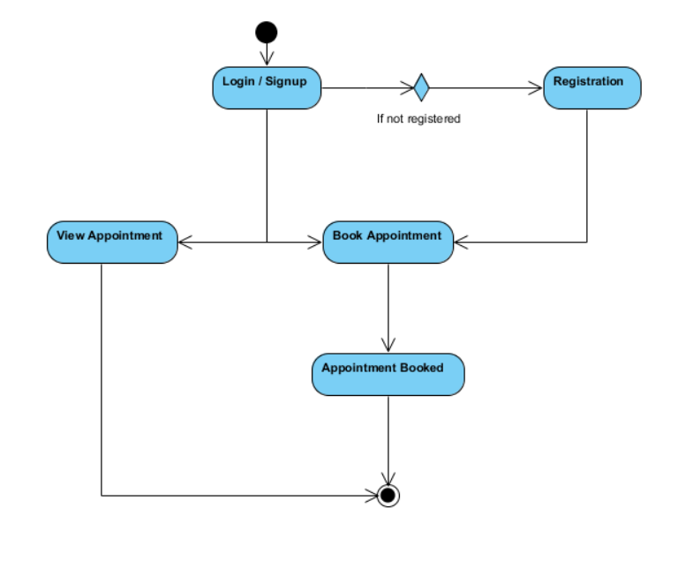

**Activity diagram of doctor:**

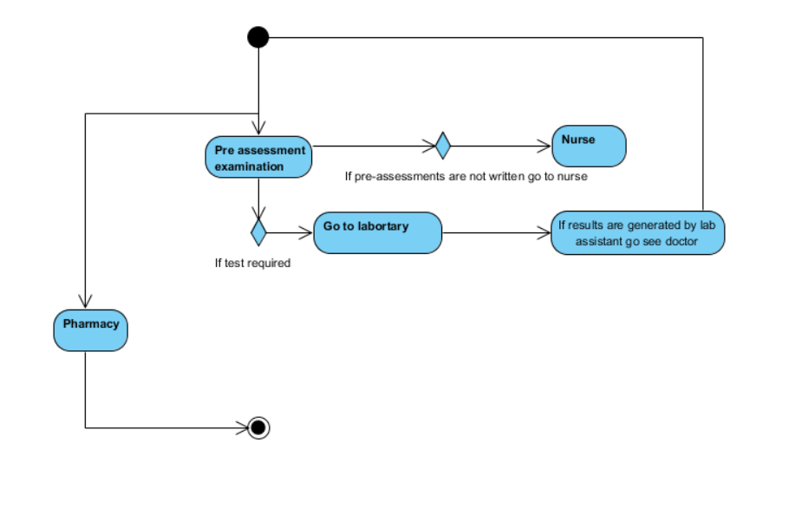

**Activity diagram for Receptionist:**

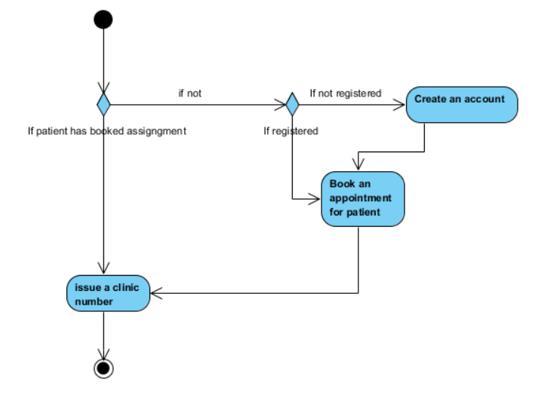

**Activity diagram of Nurses:**

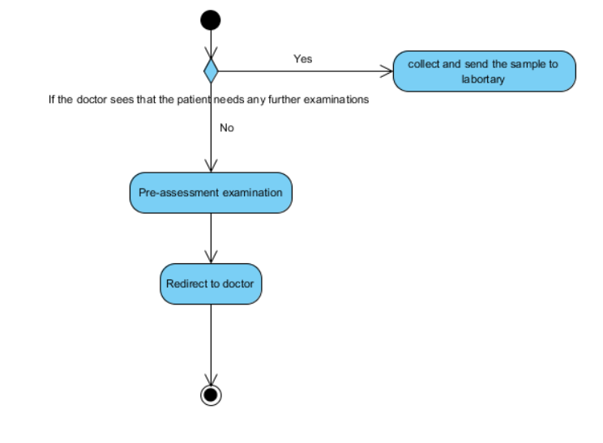

**Activity diagram of Lab Assistant:**

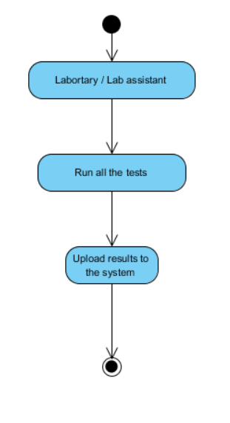

**Activity diagram of Pharmacist:**

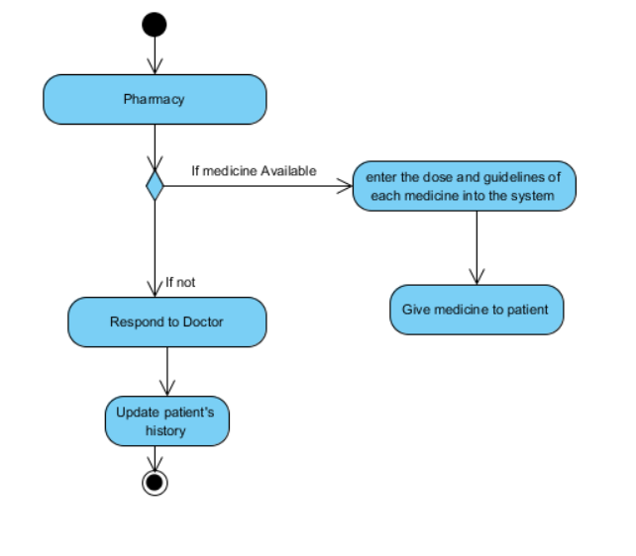

**Activity diagram of Cashier:**

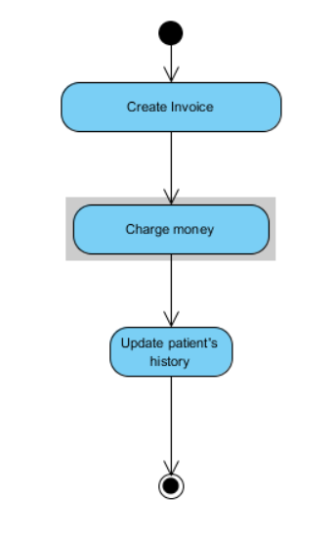

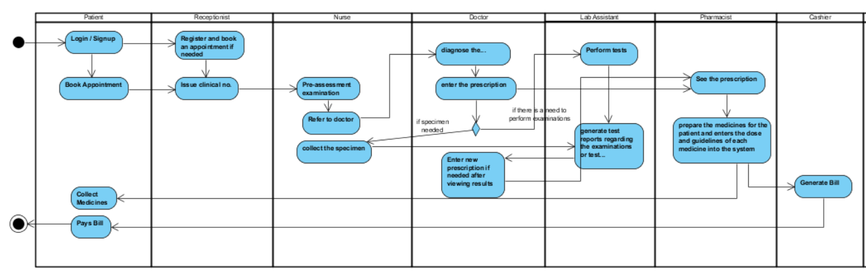**Swimlane Diagram**